**VISUALISATION TOOL FOR ELECTRIC VEHICLE CHARGE AND RANGE ANALYSIS**

**INTRODUCTION**:

OVERVIEW : Electric vehicle (EV) charge analysis is the process of analyzing and optimizing the charging patterns of electric vehicles. This analysis allows EV owners to understand the energy requirements of their vehicle and optimize the charging schedule to reduce energy consumption and charging time. Electric vehicle charge analysis includes monitoring the EV's charging status, charging times, and estimating the range of the vehicle based on battery level and other parameters.

**PURPOSE**:

The need for electric vehicle charge analysis has arisen due to the increased adoption of electric vehicles as an alternative to traditional gasoline-powered vehicles. Electric vehicles have a limited range and require frequent charging, making it essential to optimize the charging schedule to avoid range anxiety and reduce charging times. Furthermore, optimizing the charging patterns can contribute to improving the energy efficiency of electric vehicles, thereby reducing greenhouse gas emissions while saving costs.

**PROBLEM DEFINITION AND DESING THINKING:**

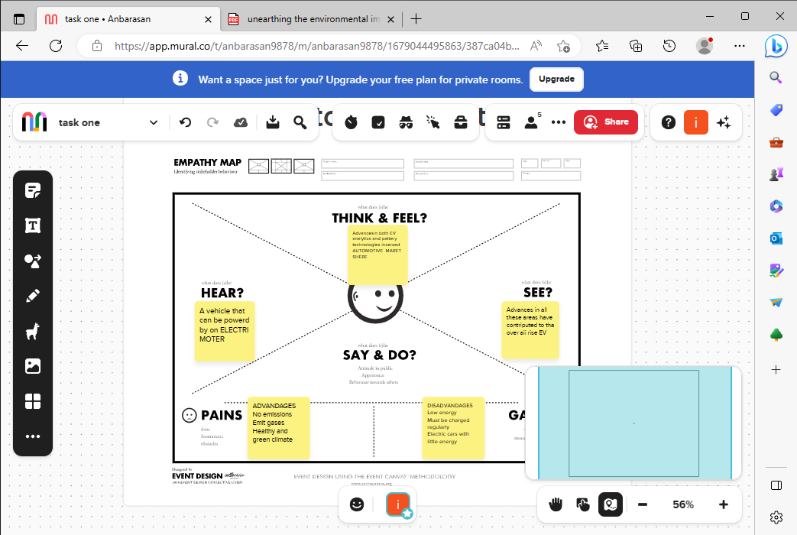

**Results:**

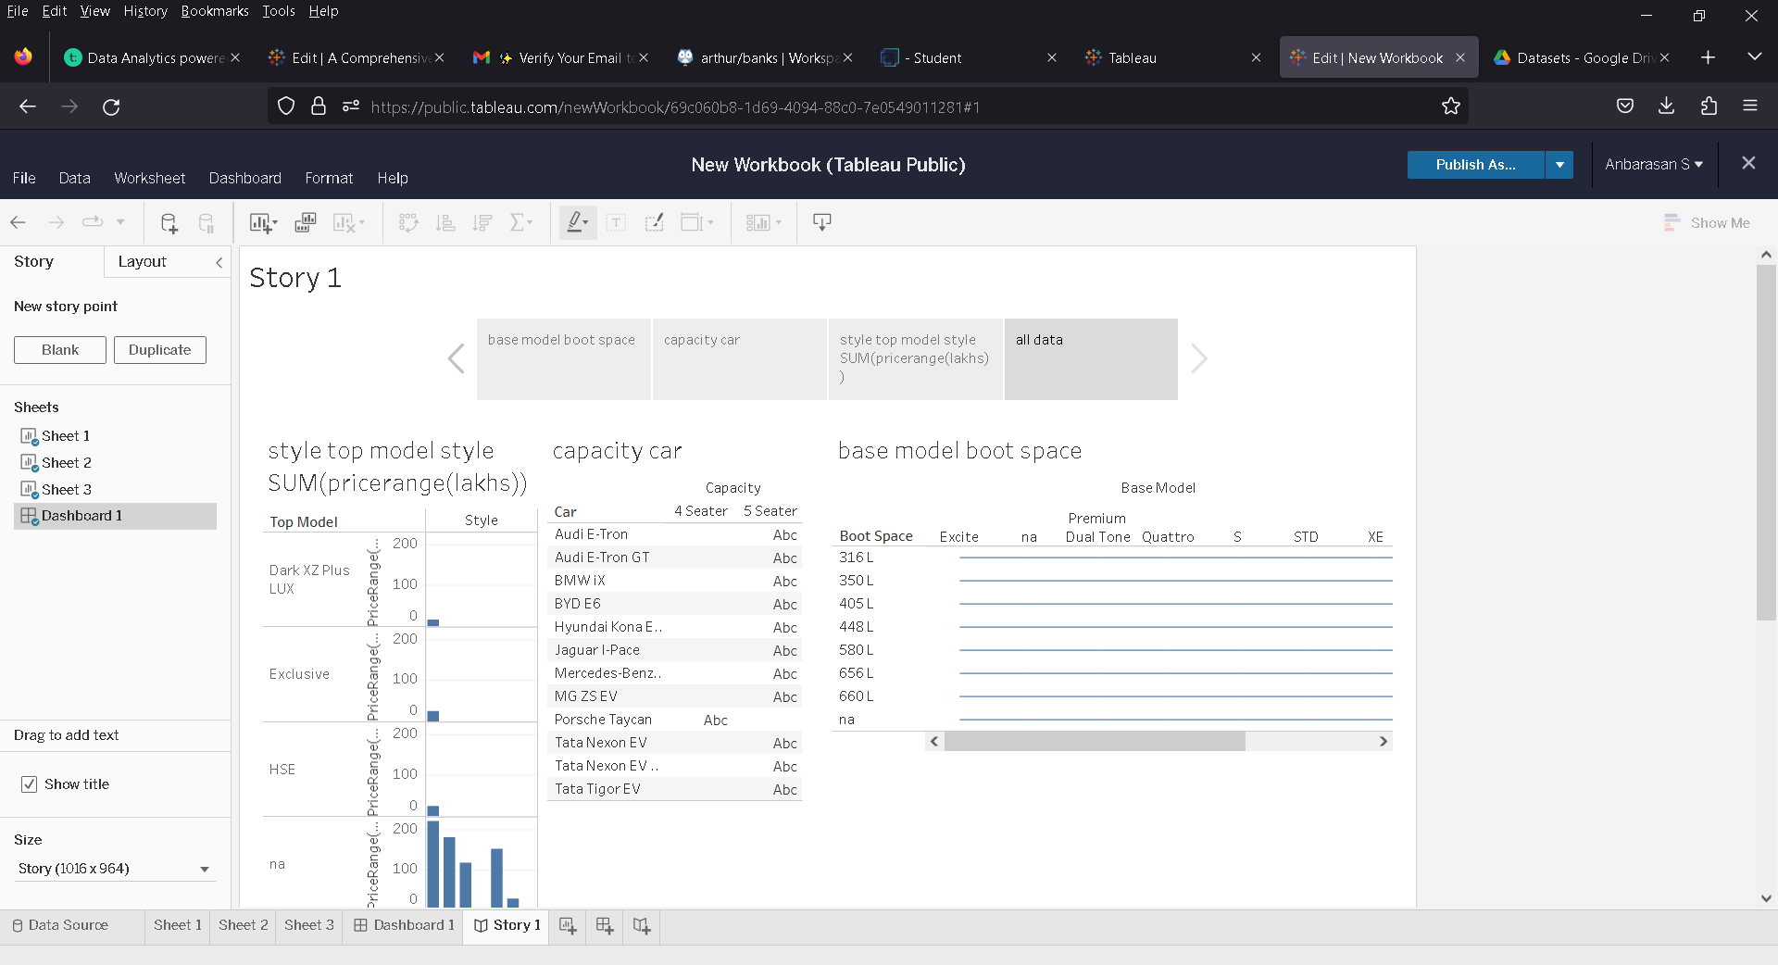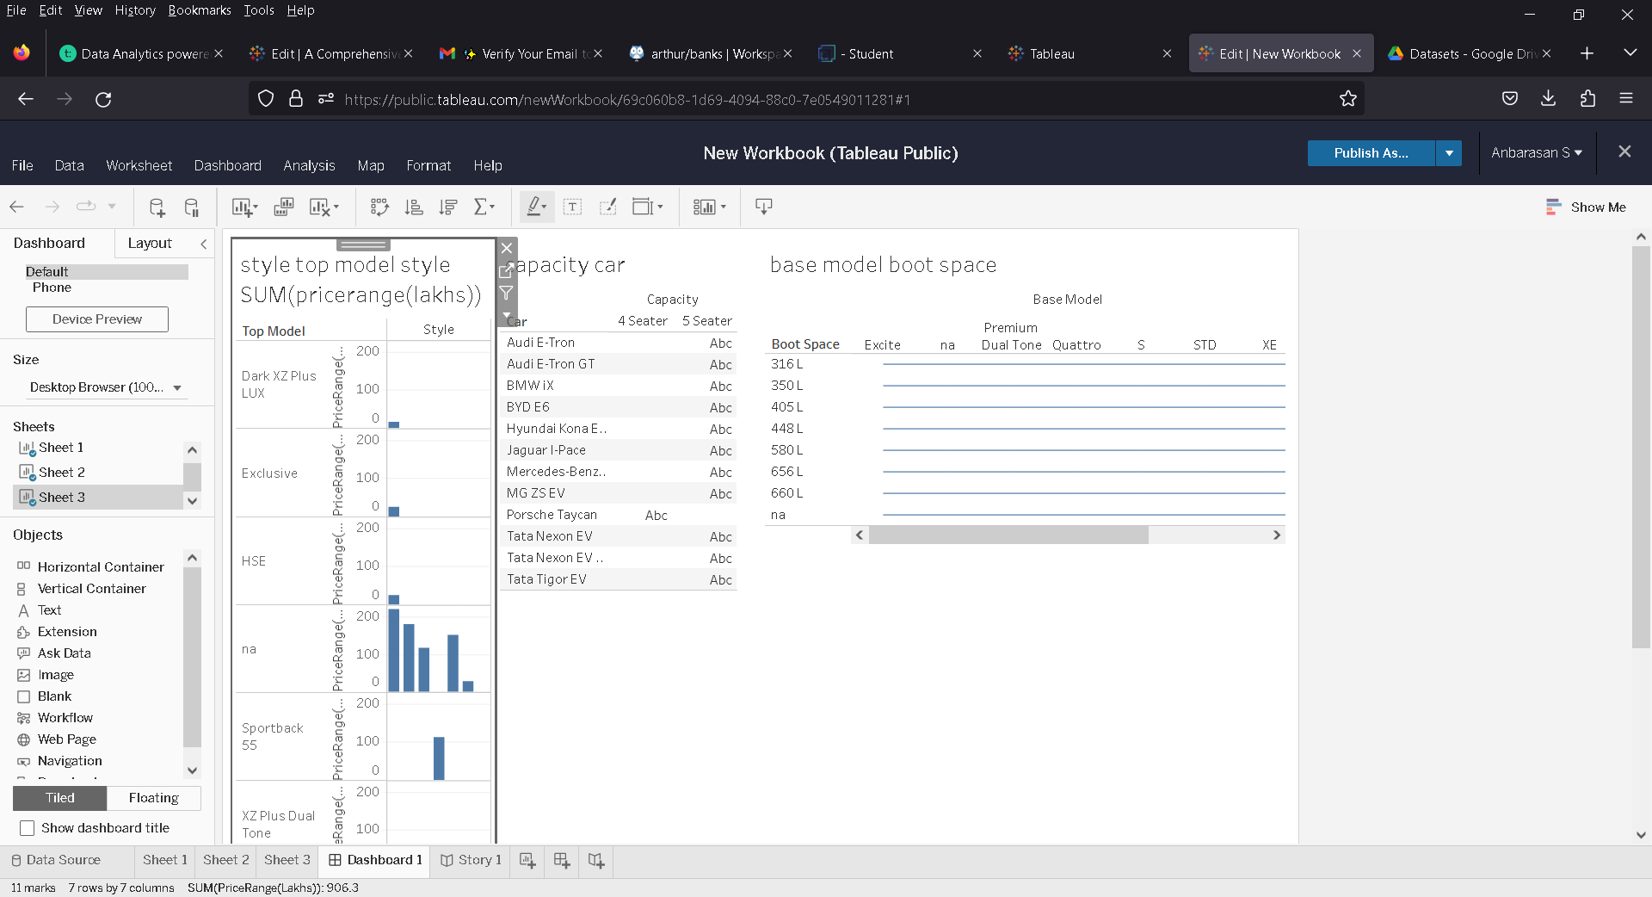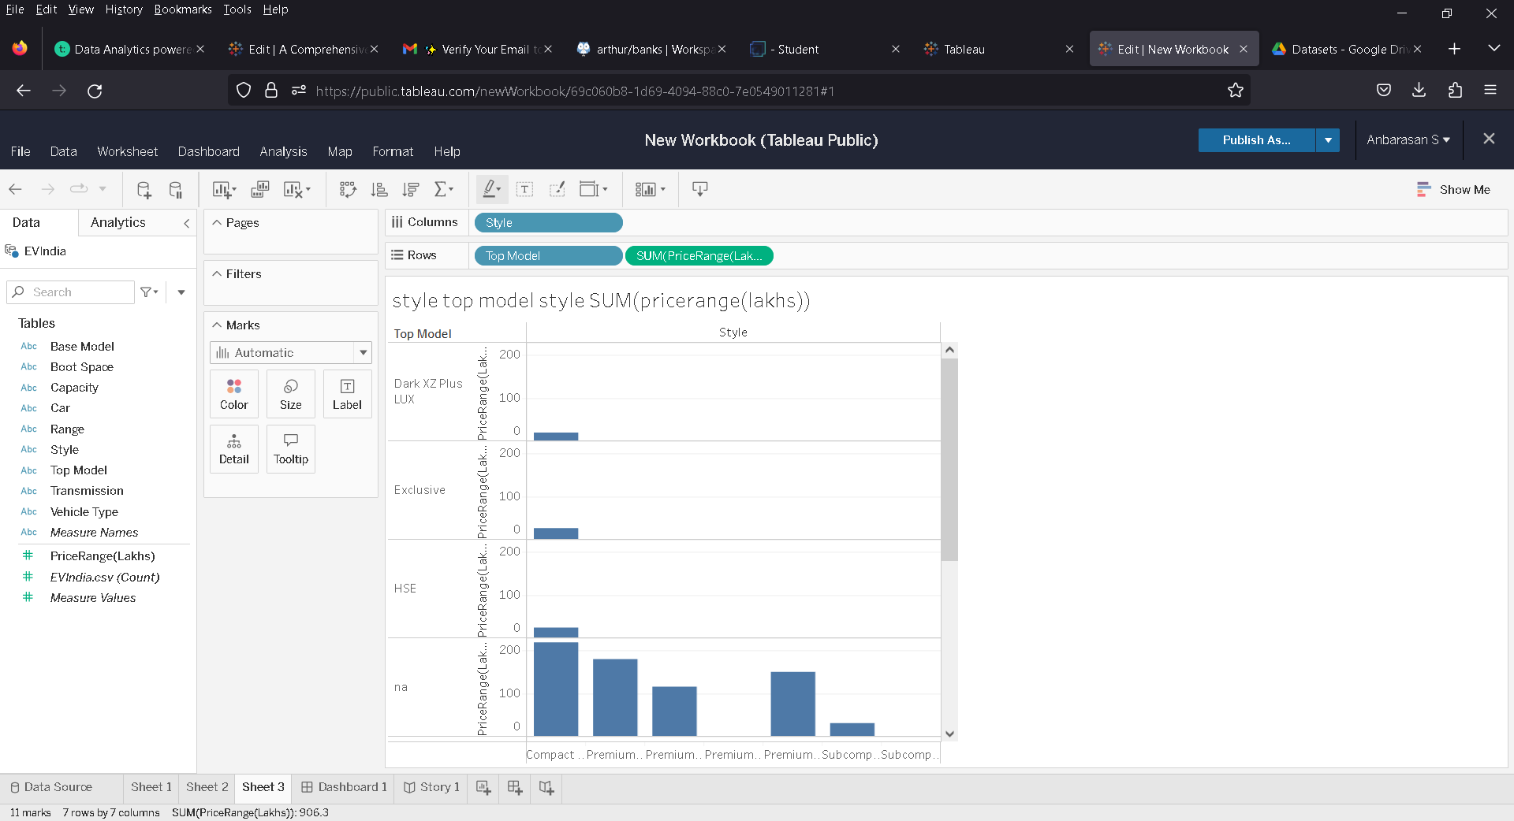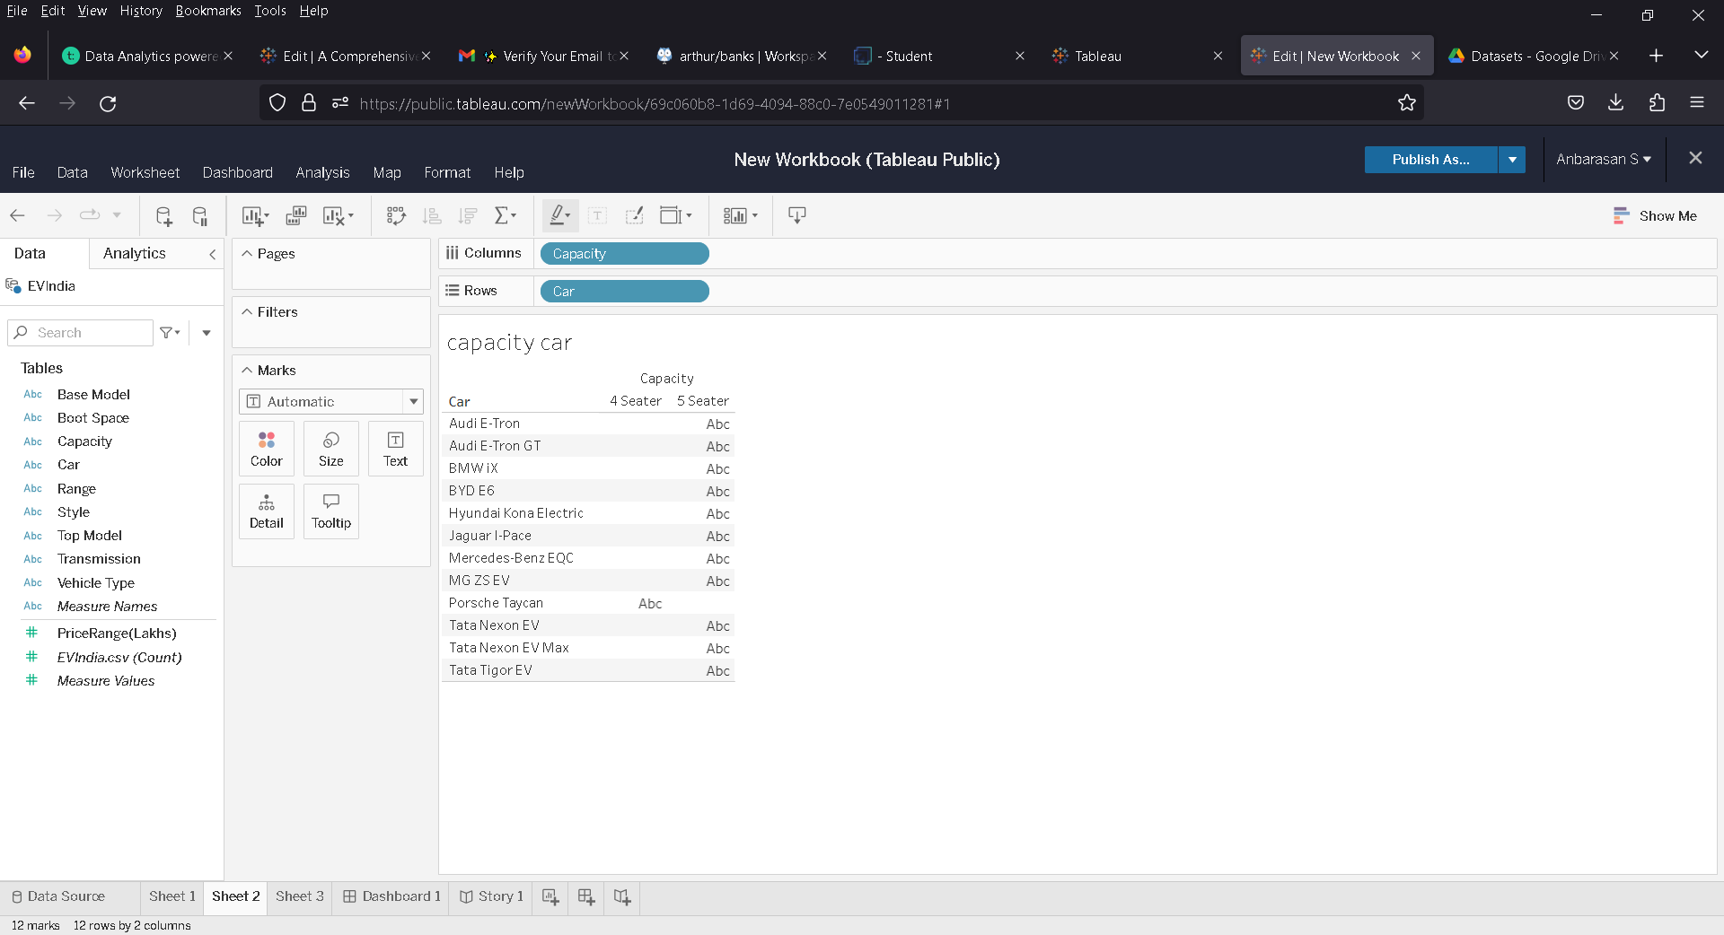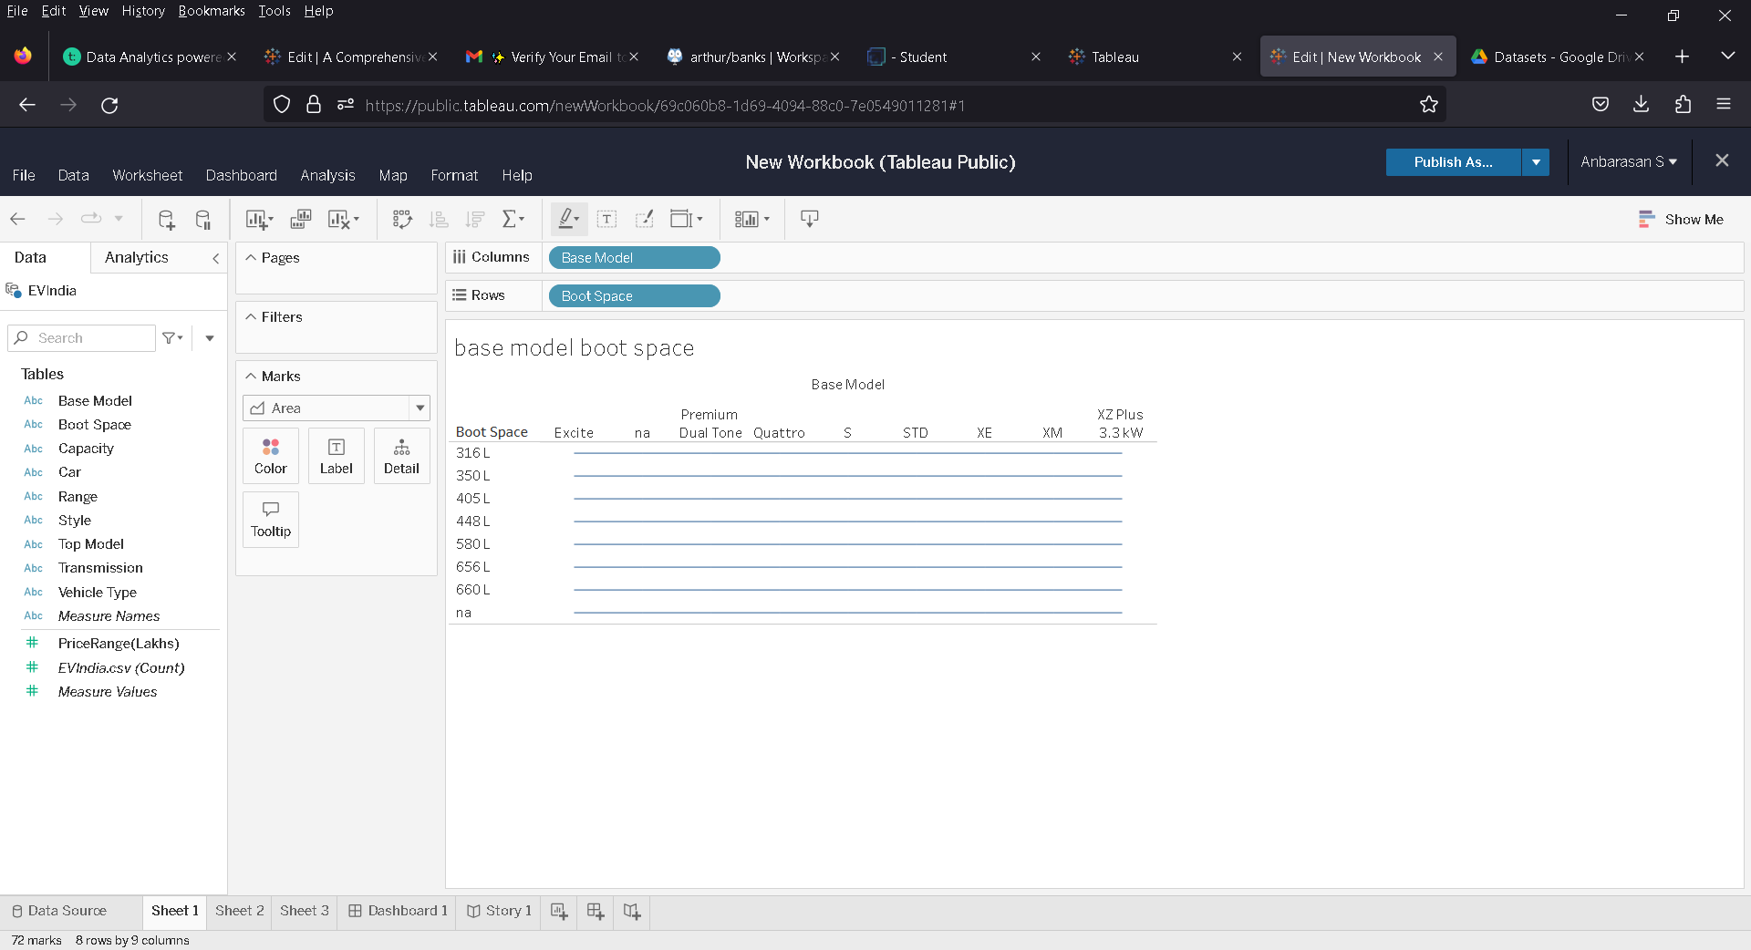

**ADVANDAGES:**

* Energy Efficiency
* Cost savings
* Environmental Benefits
* Range Anxiety

**DISADVANTAGES:**

* Limited range
* Dependence on Electricity
* Charing Time

**APPLICATIONS:**

* Optimize charging schedule
* Reduced charging costs
* Increase range
* Predict charging time
* Reduce carbon emission

**CONCLUSION:**

Electric vehicle charge analysis technologies and machine learning algorithms help optimize charging schedules, estimate the charging time, and increase the range of the EVs. They also contribute towards reducing carbon emissions and improving battery lifespan.

**FUTURE SCOPE:**

* Wireless charging
* Vehicle to grid integration
* Energy storage
* Charging on the fly